Markup Languages

📌 Definition:
# Source: AI Source: Provided by: [Data Path: Persons Table -> ID Column: 1, Name_En Column: Motasem Essam] -> From: [ChatGPT] on [12/9/2025]
Markup languages are DSLs used to structure, organize, and describe content, especially documents and web pages.

🏷️ Types of Markup Languages
# Source: AI Source: Provided by: [Data Path: Persons Table -> ID Column: 1, Name_En Column: Motasem Essam] -> From: [ChatGPT] on [12/9/2025]
Markup languages (a type of DSL) can be grouped based on how they describe and structure content.

🧩 1. Presentational Markup
# Source: AI Source: Provided by: [Data Path: Persons Table -> ID Column: 1, Name_En Column: Motasem Essam] -> From: [ChatGPT] on [12/9/2025]
- Focuses on how content looks (appearance)
- Defines style directly inside the content
📌 Example:
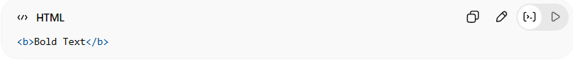
<b>Bold Text</b>
👉 Old HTML used this a lot

🧩 2. Descriptive (Semantic) Markup
# Source: AI Source: Provided by: [Data Path: Persons Table -> ID Column: 1, Name_En Column: Motasem Essam] -> From: [ChatGPT] on [12/9/2025]
- Focuses on what the content means (structure/meaning)
- Separates content from presentation
📌 Example:
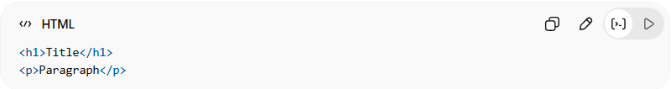
<h1>Title</h1>
<p>Paragraph</p>
👉 Modern HTML uses this approach

🧩 3. Procedural Markup
# Source: AI Source: Provided by: [Data Path: Persons Table -> ID Column: 1, Name_En Column: Motasem Essam] -> From: [ChatGPT] on [12/9/2025]
- Includes instructions on how to process content
- Tells the system what actions to perform
📌 Example:
- Older systems where commands control formatting step-by-step
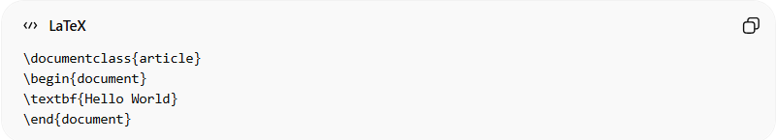
\documentclass{article}
\begin{document}
\textbf{Hello World}
\end{document}

🧩 4. Hybrid Markup
# Source: AI Source: Provided by: [Data Path: Persons Table -> ID Column: 1, Name_En Column: Motasem Essam] -> From: [ChatGPT] on [12/9/2025]
- Combines multiple types (presentation + structure + logic)
📌 Example:
- HTML + CSS + JavaScript together
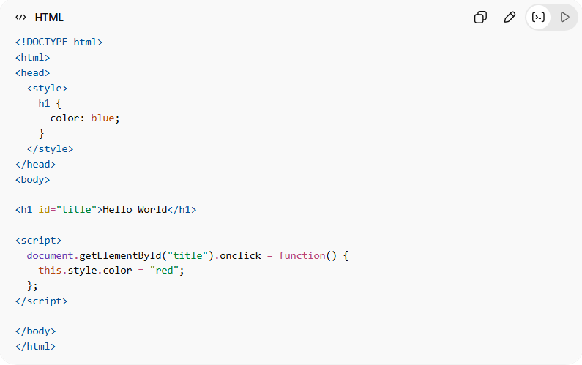
<!DOCTYPE html>
<html>
<head>
<style>
h1 {
color: blue;
}
</style>
</head>
<body>

<h1 id="title">Hello World</h1>

<script>
document.getElementById("title").onclick = function() {
this.style.color = "red";
};
</script>

</body>
</html>

🧠 Simple Summary:
# Source: AI Source: Provided by: [Data Path: Persons Table -> ID Column: 1, Name_En Column: Motasem Essam] -> From: [ChatGPT] on [12/9/2025]
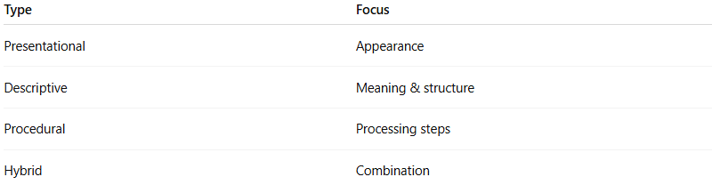
Type | Focus
Presentational | Appearance
Descriptive | Meaning & structure
Procedural | Processing steps
Hybrid | Combination

🎯 Summary:
# Source: AI Source: Provided by: [Data Path: Persons Table -> ID Column: 1, Name_En Column: Motasem Essam] -> From: [ChatGPT] on [12/9/2025]
Markup languages can describe how content looks, what it means, or how it should be processed—depending on the type.

🧩 Common Examples:

🌐 HTML (HyperText Markup Language)
# Source: AI Source: Provided by: [Data Path: Persons Table -> ID Column: 1, Name_En Column: Motasem Essam] -> From: [ChatGPT] on [12/9/2025]
- Used to structure web pages
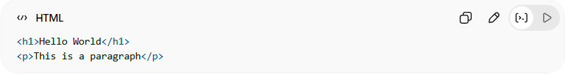
<h1>Hello World</h1>
<p>This is a paragraph</p>

📄 XML (Extensible Markup Language)
# Source: AI Source: Provided by: [Data Path: Persons Table -> ID Column: 1, Name_En Column: Motasem Essam] -> From: [ChatGPT] on [12/9/2025]
- Used to store and transport data
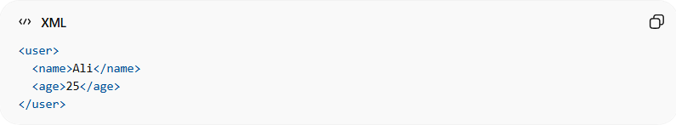
<user>
<name>Ali</name>
<age>25</age>
</user>

📝 Markdown
# Source: AI Source: Provided by: [Data Path: Persons Table -> ID Column: 1, Name_En Column: Motasem Essam] -> From: [ChatGPT] on [12/9/2025]
- Used for simple text formatting (docs, README files)
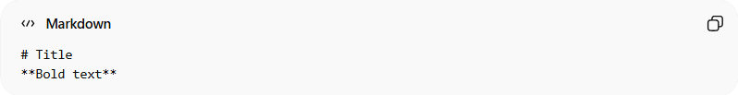
# Title
**Bold text**

📚 SGML (Standard Generalized Markup Language)
# Source: AI Source: Provided by: [Data Path: Persons Table -> ID Column: 1, Name_En Column: Motasem Essam] -> From: [ChatGPT] on [12/9/2025]
- Older markup language (basis for HTML/XML)

⚙️ What they all do:
# Source: AI Source: Provided by: [Data Path: Persons Table -> ID Column: 1, Name_En Column: Motasem Essam] -> From: [ChatGPT] on [12/9/2025]
- Define structure 🏗️
- Organize content 📄
- Describe data layout

🆚 Key idea:
# Source: AI Source: Provided by: [Data Path: Persons Table -> ID Column: 1, Name_En Column: Motasem Essam] -> From: [ChatGPT] on [12/9/2025]
All markup languages are:
- ✅ DSLs (Domain-Specific Languages)
- ❌ Not programming languages (no logic like loops/conditions)

🎯 Summary:
# Source: AI Source: Provided by: [Data Path: Persons Table -> ID Column: 1, Name_En Column: Motasem Essam] -> From: [ChatGPT] on [12/9/2025]
Markup languages are DSLs designed to structure and describe content, especially for documents and web pages.

